|  |  |  |
| --- | --- | --- |
| **Lyng Primary School P.E Knowledge Organiser** | | |
| **Topic: DANCE** | Year 4 | Spring 2 |





**Enquiry Questions**

* What is counting the beat?
* Can we apply unison to a dance routine?
* What do we need to think of when planning to create our own dance routine?
* Can we begin to create our own dance routine?
* How can we apply cannon and unison to our routine?
* Can we evaluate each other’s dance routine?

|  |  |
| --- | --- |
| **Key words** | |
| **Spelling** | **Definition** |
| Beats | Counting the beats of the song by using beats of 4 to stay with the rhythm of music. |
| Cannon | Is where individuals perform the same dance move at different times. |
| Rhythm | Applying dance moves that are linked and are able to flow |
| Unison | When two or more dancers dance with the same movements at the same time. |
| Step | Move feet with weight transfer. |

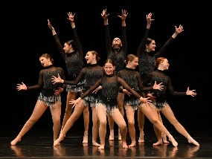

***“Dance is the joy of movement and the heart of life”***

**– Mav Levy**

|  |  |  |
| --- | --- | --- |
| **Lyng Primary School P.E Knowledge Organiser** | | |
| **Topic: DANCE** | Year 4 | Spring 2 |

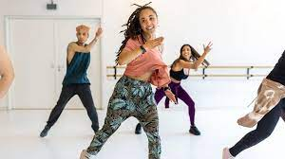

Learning Outcomes

* To be able to count beats whilst dancing.
* To be able to apply unison to a dance.
* To be able to structure and plan our own dance routine.
* To create our own dance routine.
* To understand how to apply cannon to a routine.
* To perform the routine to the rest of the class and to be able to analyse.